1. INTRODUCTION TO HTML
HTML stands for Hyper Text Markup Language. It is used to design web pages using markup language. HTML is the combination of Hypertext and Markup language. Hypertext defines the link between the web pages. Markup language is used to define the text document within tag which defines the structure of web pages. This language is used to annotate (make notes for the computer) text so that a machine can understand it and manipulate text accordingly. Most of markup (e.g. HTML) languages are human readable. Language uses tags to define what manipulation has to be done on the text.HTML is a markup language which is used by the browser to manipulate text, images and other content to display it in required format. HTML was created by Tim Berners-Lee in 1991. The first ever version of HTML was HTML 1.0 but the first standard version was HTML 2.0 which was published in 1999.

HTML page structure
The Basic structure of HTML page is given below. It contain some elements like head, title, body, etc. These elements are used to build the blocks of web pages.
<DOCTYPE! html>: This tag is used to tells the HTML version. This currently tells that the version is HTML 5.

<html>: This is called HTML root element and used to wrap all the code.
<head>: Head tag contains metadata, title, page CSS etc. All the HTML elements that can be used inside the <head> element are:
- <style>
- <title>
- <base>
- <noscript>
- <script>
- <meta>
- <title>
<body>:
Body tag is used to enclosed all the data which a web page has from texts to links. All of the content that you see rendered in the browser is contained within this element.
Example: HTML page can be created using any text editor (notepad). Then save that file using .htm or .html extension and open that file in browser. It will get the HTML page response.

Features of HTML
- It is easy to learn and easy to use.
- It is platform independent.
- Images, video and audio can be added to a web page.
- Hypertext can be added to text.
- It is a markup language.
Why learn HTML?
- It is a simple markup language. Its implementation is easy.
- It is used to create a website.
- Helps in developing fundamentals about web programming.
- Boost professional career.

Advantages
- HTML is used to build a websites.
- It is supported by all browsers.
- It can be integrated with other languages like CSS, JavaScript etc.

Disadvantages
- HTML can create only static webpages so for dynamic web page other languages have to be used.
- Large amount of code has to be written to create a simple web page.
- Security feature is not good.

Syntax
<!DOCTYPE html>
<html>
<head>
<title> </title>
</head>
<body>

</body>
</html>

2. INTRODUCTION TO CSS
Cascading Style Sheets, fondly referred to as CSS, is a simple design language intended to simplify the process of making web pages presentable.
CSS handles the look and feel part of a web page. Using CSS, you can control the colour of the text, the style of fonts, the spacing between paragraphs, how columns are sized and laid out, what background images or colours are used, layout designs, variations in display for different devices and screen sizes as well as a variety of other effects.
CSS is easy to learn and understand but it provides powerful control over the presentation of an HTML document. Most commonly, CSS is combined with the markup languages HTML or XHTML.
HTML was originally designed as a simple way of presenting information, with the aesthetics Of a web page being far less important than the content (and largely being left up to the web browser). Of course, now that the web has become as popular as it has, the presentation of your content has become almost critical to a site’s success. CSS is the key presentational technology that is used to design websites.

Benefits:
- Pages download faster, sometimes by as much as 50%
- You have to type less code, and your pages are shorter and neater.
- The look of your site is kept consistent throughout all the pages that work off the same stylesheet.
- Updating your design and general site maintenance are made much easier, and errors caused by editing multiple HTML pages occur far less often.
Well-authored CSS also improves the accessibility of web content, allowing access through myriad devices (handheld PDAs for example) and ensuring that web users with disabilities are still able to receive it. It also eliminates the need for browser-specific hacks and tags, and there are dozens of powerful extra formatting options and possibilities available through stylesheet commands that are not possible through normal html. You’ll see these later on when we get on things like backgrounds, spacing, layers and borders.
You have to type less code, and your pages are shorter and neater.
The look of your site is kept consistent throughout all the pages that work off the same stylesheet.

Types of CSS
- Inline CSS
- Internal CSS
- External CSS

I. Inline CSS
In Inline CSS every style content is in HTML elements. It is used for a limited section.
Whenever our requirements are very small we can use inline CSS. It will affect only single elements. In HTML we require that various HTML tag's views are different so then we use inline Cascading Style Sheets.
There is a disadvantage of inline Cascading Style Sheets. It must be specified on every HTML tag. There is a lot of time consumed by that and it is not the best practice for a good programmer and the code will be quite large and very complex.

II. Internal CSS
In Internal CSS the style of CSS is specified in the <head> section. This is internal CSS, it affects all the elements in the body section. Internal CSS is used in the condition when we want a style to be used in the complete HTML body. For that, we can use the style in the head tag.

III. External CSS
In External CSS we create a .css file and use it in our HTML page as per our requirements. Generally, external Cascading Style Sheets are used whenever we have many HTML attributes and we can use them as required; there is no need to rewrite the
CSS style again and again in a complete body of HTML that inherits the property of the CSS file.

Implementation
CSS files are termed “cascading” stylesheets because of two reasons: one stylesheet can cascade, or have influence over, multiple pages. Similarly, many CSS files can define a single page.
There are 3 ways to implement CSS commands into your site:
- Use one CSS file for all your pages. This is the best way to do it.
- Integrate CSS commands into the head of each of your documents.
- Use the style attribute to put CSS code directly into a HTML element.

Advantages of CSS
CSS saves time − You can write CSS once and then reuse same sheet in multiple HTML pages. You can define a style for each HTML element and apply it to as many Web pages as you want.

Pages load faster − If you are using CSS, you do not need to write HTML tag attributes every time. Just write one CSS rule of a tag and apply it to all the occurrences of that tag. So less code means faster download times

Easy maintenance − To make a global change, simply change the style, and all elements in all the web pages will be updated automatically.

Superior styles to HTML − CSS has a much wider array of attributes than HTML, so you can give a far better look to your HTML page in comparison to HTML attributes.
Multiple Device Compatibility − Style sheets allow content to be optimized for more than one type of device. By using the same HTML document, different versions of a
website can be presented for handheld devices such as PDAs and cell phones or for printing.
Global web standards − Now HTML attributes are being deprecated and it is being recommended to use CSS. So its a good idea to start using CSS in all the HTML pages to make them compatible to future browsers.

3. INTRODUCTION TO JAVASCRIPT
JavaScript is a lightweight, interpreted programming language. It is designed for creating network-centric applications. It is complimentary to and integrated with Java. JavaScript is very easy to implement because it is integrated with HTML. It is open and crossplatform.

Why to Learn JavaScript
JavaScript is a MUST for students and working professionals to become a great Software Engineer specially when they are working in Web Development Domain.
- JavaScript is the most popular programming language in the world and that makes it a programmer’s great choice. Once you learnt JavaScript, it helps you developing great front-end as well as back-end software’s using different JavaScript based frameworks like jQuery, Node.JS etc.
. JavaScript is everywhere, it comes installed on every modern web browser and so to learn JavaScript you really do not need any pecial environment setup. For example Chrome, Mozilla
- Firefox , Safari and every browser you know as of today, supports JavaScript.
- JavaScript helps you create really beautiful and crazy fast websites. You can develop your website with a console like look and feel and give your users the best Graphical User Experience.
- JavaScript usage has now extended to mobile app development, desktop app development, and game development. This opens many opportunities for you as JavaScript Programmer.
- Due to high demand, there is tons of job growth and high pay for those who know JavaScript. You can navigate over to different job sites to see what having JavaScript skills looks like in the job market.
- Great thing about JavaScript is that you will find tons of frameworks and Libraries already developed which can be used directly in your software development to reduce your time to market.
There could be 1000s of good reasons to learn JavaScript Programming. But one thing for sure, to learn any programming language, not only JavaScript, you just need to code, and code and finally code until you become expert.
There are many useful JavaScript frameworks and libraries available:
- Angular
- React
- jQuery
- Vue.js
- Ext.js
- Ember.js
- Meteor
- Mithril
- Node.js
- Polymer
- Aurelia
- Backbone.js
It is really impossible to give a complete list of all the available JavaScript frameworks and libraries. The JavaScript world is just too large and too much new is happening.
Applications of JavaScript Programming
JavaScript is one of the most widely used programming languages (Front-end as well as Backend). It has it's presence in almost every area of software development.
There are some applications of JavaScript.

- Client side validation - This is really important to verify any user input before submitting it to the server and JavaScript plays an important role in validating those inputs at front-end itself.
- Manipulating HTML Pages - JavaScript helps in manipulating
HTML page on the fly. This helps in adding and deleting any HTML tag very easily using javascript and modify your HTML to change its look and feel based on different devices and requirements.
- User Notifications - You can use JavaScript to raise dynamic pop-ups on the webpages to give different types of notifications to your website visitors.
- Back-end Data Loading - JavaScript provides Ajax library which helps in loading back-end data while you are doing some other processing. This really gives an amazing experience to your website visitors.
Presentations - JavaScript also provides the facility of creating presentations which gives website look and feel.
- JavaScript provides Reveal JS and Be spoke JS libraries to build a web-based slide presentations.
- Server Applications - Node JS is built on Chrome's JavaScript runtime for building fast and scalable network applications. This is an event based library which helps in developing very sophisticated server applications including Web Servers.
This list goes on, there are various areas where millions of software developers are happily using JavaScript to develop great websites and others software’s.
Syntax
<script type=’’text/javascript’’>

4. INTRODUCTION TO PHP
The PHP Hypertext Pre-processor (PHP) is a programming language that allows web developers to create dynamic content that interacts with databases. PHP is basically used for developing web based software applications.
Why to Learn PHP?
PHP started out as a small open source project that evolved as more and more people found out how useful it was. Rasmus Lerdorf unleashed the first version of PHP way back in 1994.
PHP is a MUST for students and working professionals to become a great Software Engineer specially when they are working in Web Development Domain.
- PHP is a recursive acronym for "PHP: Hypertext Preprocessor".
- PHP is a server side scripting language that is embedded in HTML. It is used to manage dynamic content, databases, session tracking, even build entire e-commerce sites.
- It is integrated with a number of popular databases, including MySQL, PostgreSQL, Oracle, Sybase, Informix, and Microsoft SQL Server.
- PHP is pleasingly zippy in its execution, especially when compiled as an Apache module on the Unix side. The MySQL server, once started, executes even very complex queries with huge result sets in record-setting time.
- PHP supports a large number of major protocols such as POP3, IMAP, and LDAP. PHP4 added support for Java and distributed object architectures (COM and CORBA), making n-tier development a possibility for the first time.
- PHP is forgiving: PHP language tries to be as forgiving as possible.
- PHP Syntax is C-Like.

Common uses of PHP
- PHP performs system functions, i.e. from files on a system it can create, open, read, write, and close them.
PHP can handle forms, i.e. gather data from files, save data to a file, through email you can send data, return data to the user.
- You add, delete, modify elements within your database through PHP.
- Access cookies variables and set cookies.
- Using PHP, you can restrict users to access some pages of your website.
- It can encrypt data.

Characteristics of PHP
Five important characteristics make PHP's practical nature possible − • Simplicity
- Efficiency • Security
- Flexibility
- Familiarity

Syntax
<?php
//PHP code goes here
?>

Applications of PHP
PHP is one of the most widely used language over the web. There are some applications of php.
- PHP performs system functions, i.e. from files on a system it can create, open, read, write, and close them.
- PHP can handle forms, i.e. gather data from files, save data to a file, through email you can send data, return data to the user.
- You add, delete, modify elements within your database through PHP.
- Access cookies variables and set cookies.
- Using PHP, you can restrict users to access some pages of your website.
- It can encrypt data.

5. INTRODUCTION TO SQL
SQL is a database computer language designed for the retrieval and management of data in a relational database. SQL stands for Structured Query Language.
SQL is the language used to create, edit and manipulate a database. In other words, SQL is used to manage data held within a relational database management system (RDBMS).
Because this is a database design series, we will not be working with SQL directly, but will design our database to work with SQL in the future (once it is completely designed and ready to be programmed). SQL is the general language used to communicate with relational database management systems. This means that we use SQL to communicate to MySQL, Oracle, SQL Server, etc… So learning about SQL will help you with a lot of different things! A RDBMS takes SQL and uses it to do something with the database.

Why to Learn SQL?
SQL is Structured Query Language, which is a computer language for storing, manipulating and retrieving data stored in a relational database.
SQL is the standard language for Relational Database System. All the Relational Database Management Systems (RDMS) like MySQL, MS Access, Oracle, Sybase, Informix, Postgres and SQL Server use SQL as their standard database language.
Also, they are using different dialects, such as − • MS SQL Server using T-SQL,
- Oracle using PL/SQL,
- MS Access version of SQL is called JET SQL (native format) etc.

What Can SQL do?
- SQL can execute queries against a database
- SQL can retrieve data from a database
- SQL can insert records in a database
- SQL can update records in a database
- SQL can delete records from a database
- SQL can create new databases
- SQL can create new tables in a database
- SQL can create stored procedures in a database
- SQL can create views in a database
- SQL can set permissions on tables, procedures, and views

Applications of SQL
SQL is one of the most widely used query language over the databases. There is some applications of SQL.
- Allows users to access data in the relational database management systems.
- Allows users to describe the data.
- Allows users to define the data in a database and manipulate that data.
- Allows to embed within other languages using SQL modules, libraries & precompilers.
- Allows users to create and drop databases and tables.
- Allows users to create view, stored procedure, functions in a database.
- Allows users to set permissions on tables, procedures and views.

6. INTRODUCTION TO PROJECT

“Hotel management system” gives idea about the management in hotels. The packages gives all the information regarding the check in Or check out facilities of the customer. Our project can not leak the information about the customer to any other person.
Although, hotels are already having Well-developed software for the Information management. So we selected hotel management system as a project. We used my SQL or PHP in back -end it is based on relational database and for front end we used HTML, CSS and JAVASCRIPT for project.
We provide the online booking facility of rooms For customer that customer can book their room by online. The customers name and contact details are added for reference. Customers can do online payment. We also provide lots of facilities like swimming, free wi-fi for Customer, playground for kids , free parking service for customer, and many more .
Admin has authorities to add hotel details. Customers can log in by his email id or password for room booking. Admin has rights to edit or delete the details for each customers.

7. SYSTEM ANALYSIS STUDY REPORT

- User Interview
  - If there is Wi-Fi available or Not?
Ans:-Yes
  - Can I able to pay online?
Ans:-Yes
  - Can I order extra breakfast?
Ans:-Yes
  - If we have booked two persons room can we stay three persons?
Ans:-No
  - Can I expand check Out date?
Ans:-Yes
  - Will I Be Able To Automatic Booking Confirmation, Reminder, And Stay Email?
Ans:-Yes
  - Will I Be Able To Display Hot Deals On The Calendar Interface?
Ans:-Yes
  - Can I expand check In date?
Ans:-No
  - Can You Provide Documented Or SMS Proof Of Payment?
Ans:- Yes
10)If there is swimming pool?
Ans:-Yes
- Problem Definition
• It is limited to system.
• It is fewer users friendly.
• The present system is very less secure.
• Unable to access all information of customer.
• Understanding the uses of internet banking might be difficult for a beginner at first go.
So person who is new might face some difficulty. You if can’t have access to secure net
Banking if you don’t have an internet connection thus without the availability of internet Access it may not be useful Security of transition is bigger issue

8. SCOPE OF SYSTEM

The world is changing and so is the meaning of hotel management. Today, hotel management. Is not only confined to hotels but have gone deep into tourism, catering, airlines, clubs etc.Making it a very paying and an exciting career option.

• With the rapid growth of hotel industry pushed forward by foreign and domesticTourism and business travels, the demand for well trained and quality personnel Too has gone up high.
• The mission of this project is to facilitate easy management and administration Of a hotel with capabilities to do Booking or reservations of the rooms, Cancellation of the rooms, creating of new user, Room service, Total billing etc.
• Using the computerized hotel management software.
• One can keep detailed records or info on an unlimited amount of customers.
• The system lets the user know which all rooms are available for occupancy at Any point of time.
• This makes the booking considerably faster. And thus helps the hotel in better Management and reduce a lot of paper work as well as manpower.

9. HARDWARE AND SOFTWARE REQUIREMENT

Software Requirements
• Notepad++
• Google Chrome
• Windows Operating System
• XAMPP

Hardware Requirements
• RAM 512 MB or Above
• HD 200 MB or Above
• CPU: Intel core duo or AMD Radeon 2.4 GHz

10. DATA FLOW DIAGRAM(DFD)
A data flow diagram (DFD) maps out the flow of information for any process or system. It Uses defined symbols like rectangles, circles and arrows, plus short text labels, to show data Inputs, outputs, storage points and the routes between each destination. Data flowcharts can range from simple, even hand-drawn process overviews, to in-depth, multi-level DFDs that dig progressively deeper into how the data is handled. They can be used to analyse an existing System or model a new one.
Symbols and Notations Used in DFDs
- External entity: an outside system that sends or receives data, communicating with the system being diagrammed. They are the sources and destinations of information entering or leaving the system. They might be an outside organization or person, a computers system or a business system. They are also known as terminators, sources and Sinks or actors. They are typically drawn on the edges of the diagram.
- Process: any process that changes the data, producing an output. It might perform computations, or sort data based on logic, or direct the data flow based on business rules. A short label is used to describe the process, such as “Submit payment.”
- Data flow: the route that data takes between the external entities, processes and data Stores. It portrays the interface between the other components and is shown with arrows, Typically labeled with a short data name, like “Billing details.”
Notation
External Entity

Process

Data Flow
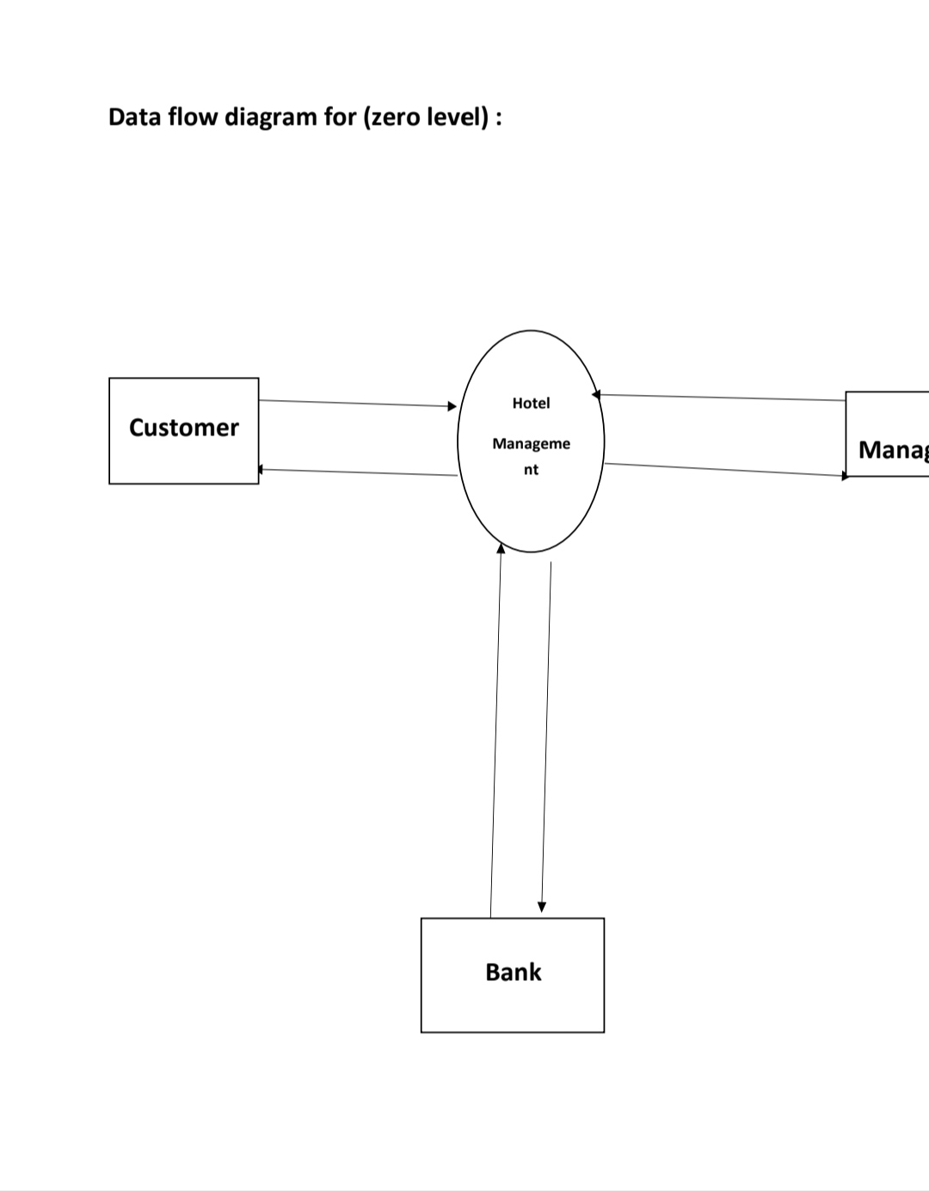

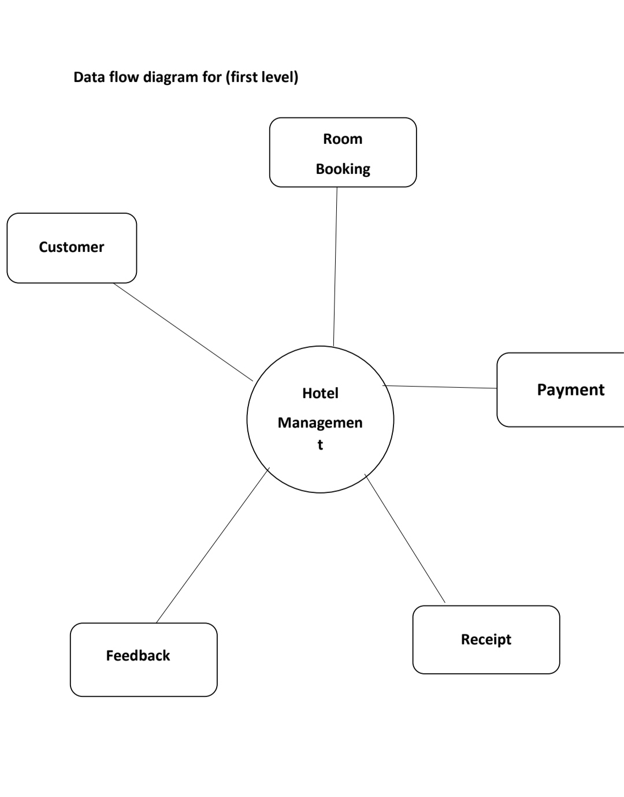
11. ENTITY RELATIONSHIP DIAGRAM

The ER or (Entity Relational Model) is a high-level conceptual data model diagram. Entity-Relation model is based on the notion of real-world entities and the relationship between them.ER modelling helps you to analyse data requirements systematically to produce a well-Designed database. So, it is considered a best practice to complete ER modelling before implementing your database. Components of the ER Diagram This model is based on three basic concepts:
• Entities
• Attributes
• Relationships
Entities:
A real-world thing either living or non-living that is easily recognizable and nonrecognizable.It is anything in the enterprise that is to be represented in our database. It may be a physical thing or simply a fact about the enterprise or an event that happens in the real world.
Attributes:

An attribute describes the property of an entity. An attribute is represented as Oval in an ER diagram. There are four types of attributes:
- Key attribute.
2. Composite attribute.
3. Multivalued attribute.
4. Derived attribute.
Relationships:
Defines the numerical attributes of the relationship between two entities or entity sets. Different types of cardinal relationships are:
• One-to-One Relationships
• One-to-Many Relationships
• May to One Relationships
• Many-to-Many Relationships

ER- Diagram Notations
ER- Diagram is a visual representation of data that describe how data is related to each other.

• Rectangles: This symbol represent entity types
• Ellipses : Symbol represent attributes
• Diamonds: This symbol represents relationship type
• Lines: It links attributes to entity types and entity types with other relationship types.
• Primary key: attributes are underlined
• Double Ellipses: Represent multi-valued attribute
• Dashed Ellipses: Derived Attributes
• Double Rectangles: Weak Entity Sets
• Double Lines: Total participation of an entity in a relationship set

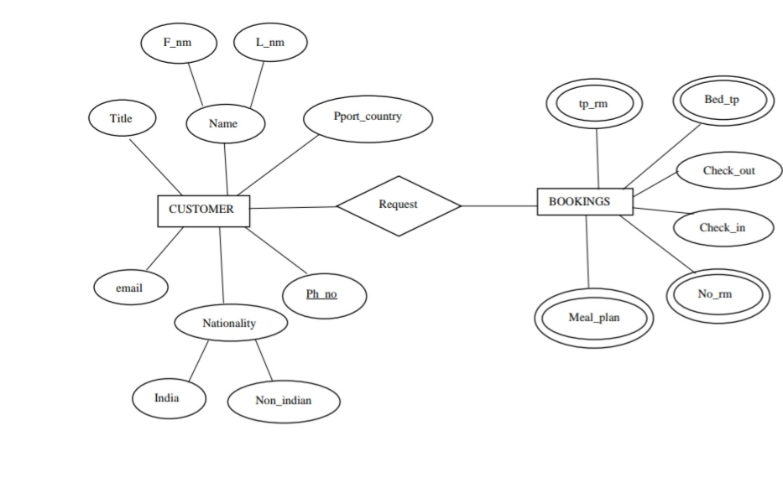

12. FEASIBILITY STUDY

A feasibility study is carried out to select the best system that must performance requirement and it’s working ability in an organization. The feasibility of the system has been done in three
Types
I. Environmental Feasibility
II. Economical Feasibility Study
- Technical Feasibility Study

- Environmental Feasibility
The environmental feasibility study considers both human and environmental health factors. The FS is a comparative process that looks at all potential solutions, then evaluates them against specific criteria to ultimately find the best choice.

- Economical Feasibility Study
In this we mainly calculate the cost of proposed system and the cost of customer and compare the cost to meet the users cost. The cost of hardware, facility cost, operating and supply costs Are considered. The cost of feasibility is also considered on this such as wiring, lightning, A.C. Etc.

- Technical Feasibility Study
Technically we have made feasibility in keeping mind about the hardware so that the designed Software can work smoothly with maximum efficiency with the hardware.
13. TESTING
Testing is the process of detecting errors. Testing performs a very critical role for quality assurance and for ensuring the reliability of software. The results of testing are used later on during maintenance also.

- White Box Testing
White Box Testing is defined as the testing of a software solution’s internal structure, design, and coding. In this type of testing, the code is visible to the tester. It focuses primarily on Verifying the flow of inputs and outputs through the application, improving design and usability, strengthening security.This is a unit testing method where a unit will be taken at a time and tested thoroughly at a statement level to find the maximum possible errors. I tested step wise every piece of code, taking care that every statement in the code is executed at least once. The white box testing is also called Glass Box Testing.
- Black Box Testing
Black box testing is defined as a testing technique in which functionality of the Application Under Test (AUT) is tested without looking at the internal code structure, implementation details and knowledge of internal paths of the software. This testing method considers a module as a single unit and checks the unit at interface and communication with other modules rather getting into details at statement level. Here the module will be treated as a block box that will take some input and generate output. Output for a given set of input combinations are forwarded to other modules.
- Cross Browser Testing
Cross Browser Testing is a type of testing to verify if an application works across different browsers as expected and degrades gracefully. It is the process of verifying your application’s compatibility with different browsers.
With such a wide range of browsers, devices, and operating systems available today, cross Browser testing is a crucial part of developing software. The purpose of cross-browser testing is To provide a consistent behaviour and experience across all browsers, devices, and platforms.

